Pratyusha Thundena

Laboratory 4

FA2017 CS 103L-F4 Introduction to Computation Lab

October 6, 2017

Source Code

Figure 1:

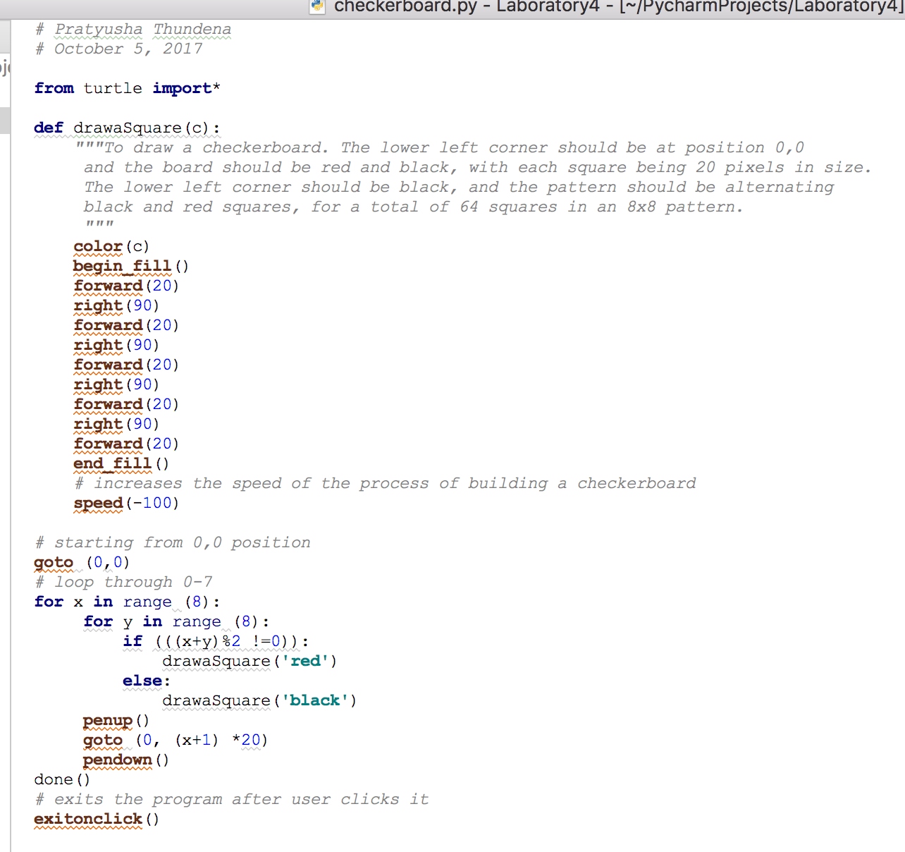

Figure 2:

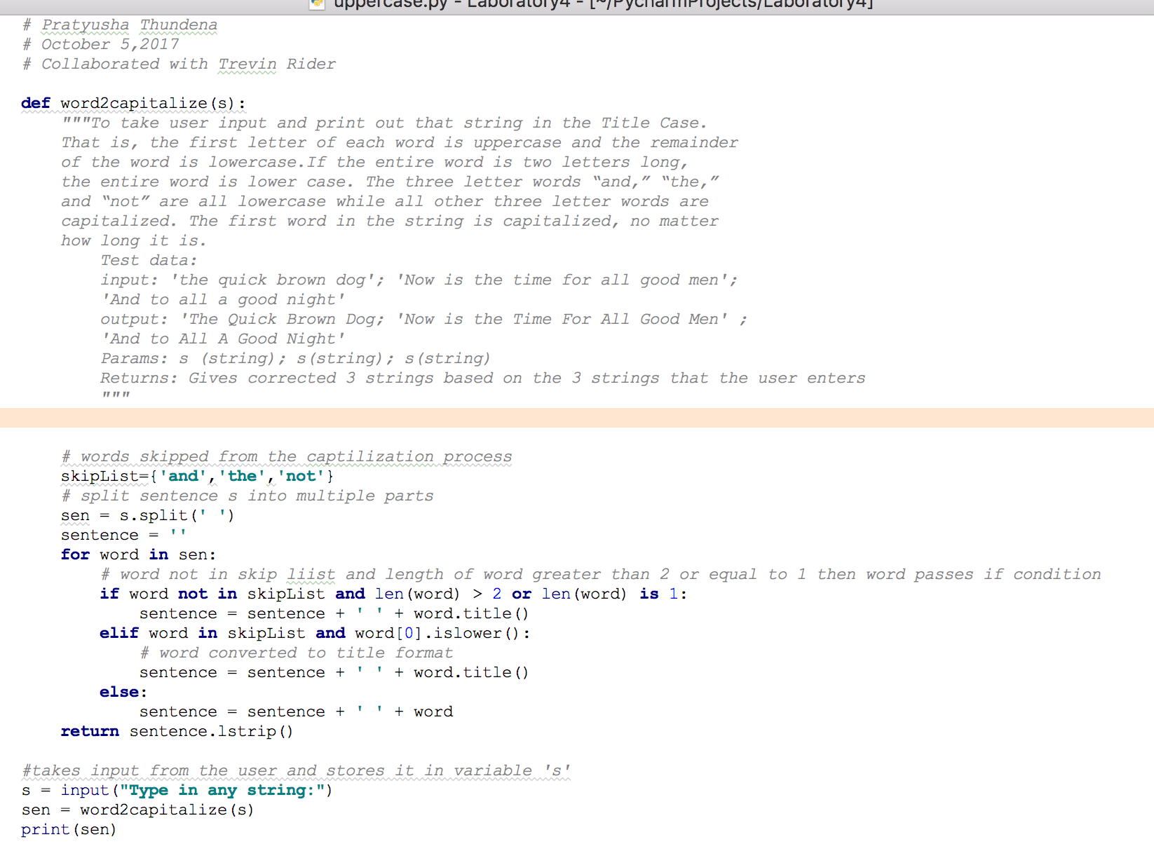

Demonstration to TA

Source codes demonstrated on 10/05/2017 at approximately 2:20 pm (CST) to BreAunna.

Program Results

Figure 1 Output:

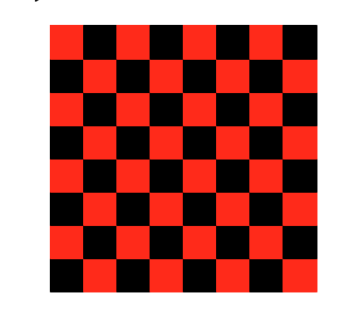

Figure 2a Output:

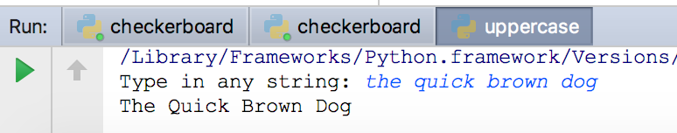

Figure 2b Output:

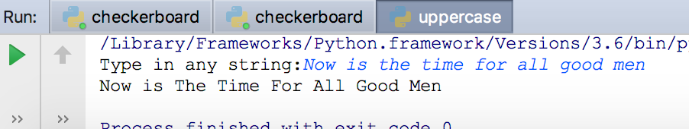

Figure 2c Output:

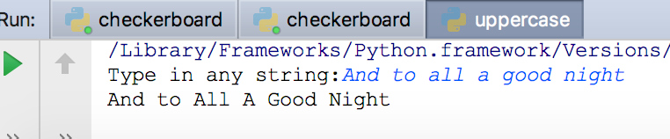

Conclusion and Results

This lab focused on creating a checkerboard using Python turtle graphics as well as

asking the user to input a string and then print out that string in the Title case. The first letter of

each word is uppercase unless it is a two-letter word or it is ‘and’, ‘the’, or ‘not’. If ‘and’ or ‘the’

or ‘not’ is the first word of the sentence, then it should be capitalized. The checkerboard lab

involved creating a grid of 64 squares with alternating pattern between black and red (Figure 1,

Figure 1 Output). The second part of lab was quite complicated to understand and it involved the

repetitive process of trial and error. The purpose of this portion of the lab was to develop the

mental skill of picking a problem apart into pieces and solving the pieces instead of seeking out

one easy solution. The skipList function allowed me to create a list of the words that I would like

to skip the capitalization process. A for loop was created to define exceptions to what can and

cannot be capitalized. If word was not in skipList and the length of the word was greater than 2

or equal to 1, then the word would have passed the if condition and gone inside. If the first if

condition failed, then the control goes to the next if condition. The second if condition allowed

me to capitalize a word in the skip list if it was the first word of the given sentence. If the word

failed both conditions, then the flow would go to the else part of the function. The built in

function strip () removed whitespace characters in the given sentence (Figure 2, Figure 2a

Output, Figure 2b Output, Figure 2c Output).